Satellite Antenna Tracking Mount

Hunter Britton

Michael Raabe

David Santos

**Interface Control Document**

REVISION – 1.0

17 February 2023

Interface Control Document

for

Satellite Antenna Tracking Mount

Prepared by:

_____________________________

Author Date

Approved by:

_____________________________

Hunter Britton Date

_____________________________

Prof. S. Kalafatis Date

_____________________________

Pranav Dhulipala Date

**Change Record**

| **Rev.** | **Date** | **Originator** | **Approvals** | **Description** |
| --- | --- | --- | --- | --- |
| **-1.0** | 2/21/2023 | David Santos |  | Draft Release |

**Table of Contents**

**1. Overview** **6**

**2. References and Definitions** **6**

2.1. References 6

2.2. Definitions 6

**3. Physical Interface** **7**

3.1. Weight 7

3.1.1. Main Control Unit 7

3.1.2. Power Supply Unit 7

3.2. Dimensions 7

3.2.1. Dimensions of MCU Subsystem 7

3.2.2. Dimensions of Power Supply Subsystem 8

3.3. Mounting Locations 8

**4. Thermal Interface** **9**

**5. Electrical Interface** **10**

5.1. Primary Input Power 10

5.1.1. Main Control Unit 10

5.1.2. L298N Motor Driver 10

5.2. Voltage and Current Levels 10

5.2.1. Maximum Values 10

**6. Communications / Device Interface Protocols** **11**

6.1. Wireless Communications (WiFi) 11

6.2. Device Peripheral Interface 11

**List of Tables**

Table 1: Main Control Unit Weight………………………………………………...7

Table 2: Power Supply Unit Weight………………………………………………..7

Table 3: MCU Dimensions…………………………………………………………7

Table 4: Power Supply Dimensions………………………………………………...8

Table 5: Maximum Electrical Values……………………………………………...10

**List of Figures**

# Figure 1: Satellite Antenna Tracking Mount System………………………………8

Figure 2: Electrical Interface Diagram……………………………………………10

# Overview

This document will show how the web application, power supply, and MCU subsystems will interface with each other. It will list all possible inputs, outputs, and how the system will manage each. First, an explanation of the inputs from the web application and how it is transferred to the MCU will be detailed. A description of how the power supply will be implemented, and how the MCU interfaces with the power supply subsystem will follow.

# References and Definitions

## References

Refer to section 2.2 of the Functional Systems Requirement document.

## Definitions

W Watt

A Amp

mA Milliamp

mW Milliwatt

TBD To Be Determined

g Grams

# Physical Interface

## Weight

**3.1.1 Main Control Unit**

| **Component** | **Weight** | **Number of Items** | **Total Weight** |
| --- | --- | --- | --- |
| Arduino Uno Board | 25 g | 1 | 25 g |
| ESP8266 | 1.72 g | 1 | 1.72 g |
| NEO-6M | 22 g | 1 | 22 g |
| 4x20 LCD Display | 76 g | 1 | 76 g |

*Table 1: Main Control Unit Weight*

**3.1.2 Power Supply Unit**

| **Component** | **Weight** | **Number of Items** | **Total Weight** |
| --- | --- | --- | --- |
| Power Supply Board | TBD | 1 | TBD |
| AC-DC Converter | TBD | 1 | TBD |
| DC-DC Boost Converter | TBD | 1 | TBD |
| Output Port | TBD | 2 | TBD |

*Table 2: Power Supply Unit Weight*

## Dimensions

Dimensions are in millimeters.

### Dimensions of MCU Subsystem

| **Component** | **Length** | **Width** | **Height** |
| --- | --- | --- | --- |
| Arduino UNO Board | 68.6 mm | 53.4 mm | 24.9 mm |
| LCD Display | 20 mm | 4 mm | N/A |

*Table 3: MCU Dimensions*

**3.2.2 Dimensions of Power Supply Subsystem**

| **Component** | **Length** | **Width** | **Height** |
| --- | --- | --- | --- |
| Power Supply Board | TBD | TBD | TBD |

*Table 4: Power Supply Dimensions*

## Mounting Locations

The Satellite Antenna Tracking Mount (SATM) should be able to be used anywhere on Earth, but will most likely be deployed in various locations around College Station, Texas. The MCU will be attached by wires to the antenna mount, but the MCU box itself will be mounted directly below the antenna mount. The power supply will be plugged into a wall outlet (most likely with an extension cord), and then the outputs of the power supply will plug directly into the MCU box.

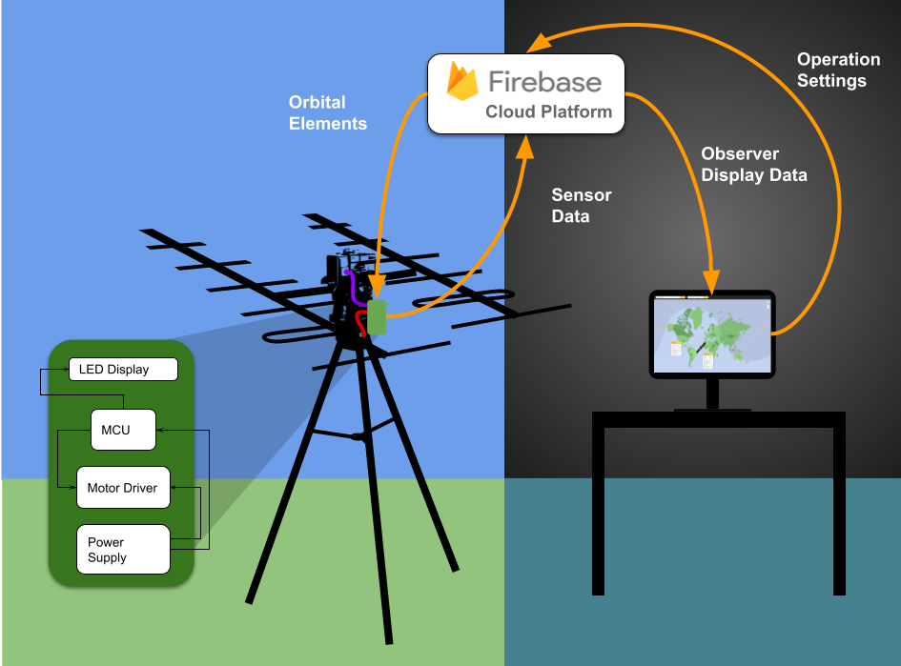

*Figure 1: Satellite Antenna Tracking Mount System*

# Thermal Interface

The L298N motor driver has a built-in heat sink. There is also a built-in heat sink for the MCU (Arduino UNO). Also, to prevent overheating of the antenna mount, the gearbox will need to be lubricated.

# Electrical Interface

*Figure 2: Electrical Interface Diagram*

## Primary Input Power

**5.1.1 Main Control Unit**

The MCU will be powered by the power supply board and will take 9V at 50 mA. It will consume a maximum of 1.8 watts of power.

**5.1.2 L298N Motor Driver**

The motor driver will be powered by the power supply board and will take 24V at 2A. The two motors together will consume a maximum of 48 watts of power.

***5.2. Voltage and Current Levels***

**5.2.1 Maximum Values**

| **Component** | **Voltage** | **Current** | **Power** |
| --- | --- | --- | --- |
| Arduino UNO | 9 V | ≤ 200 mA | 1.8 W |
| L298N Motor Driver | 24 V | ≤ 2 A | 48 W |

*Table 5: Maximum Electrical Values*The values in table 5 allow for gauging how much power the system will use, per second, at peak power consumption. It is estimated that the system will be at peak power most of the time because the motors will be running constantly to track the satellite.

# Communications / Device Interface Protocols

## Wireless Communications (WiFi)

Using IEEE 802.11ac the Satellite Antenna Tracking Mount will connect to a user's device and network to upload and download data.

## Device Peripheral Interface

The device will have custom connectors to send a digital signal to the customers existing system in order to control the motors on the existing system.

## 

## 

## 

## 